**Paper A**

**3. Can a serious case be made for the literature of sensibility on aesthetic and/or ethical and/or political grounds? Discuss at least three literary texts from your reading list in at least two different genres.**

The literature of sensibility — which I take to encompass sentimental literature through its evolution into the gothic — presents a value system based in feeling, but engaged in a constant negotiation regarding the failure points of its own convictions. For a work to successfully provide the pleasurable aesthetic experience of “virtue in distress,” it must articulate compelling ethical definitions of both “distress” and “virtue.” A detailed examination of individual works’ navigation of these concepts, and of the mental pleasures they offer to readers, may not constitute a “serious” case, but, following Eve Sedgwick and Rita Felski, it attempts a *feeling* case. Accordingly, I examine *The Vicar of Wakefield*, *A Simple Story*, and *The Captive*, attentive to the terms by which each recommends an embrace of misery.

There is a substantial body of literary criticism beginning in the 1960s which treats Oliver Goldsmith's *The Vicar of Wakefield* (1766) as a satirical novel. As Vera Nünning points out, however, readers in the 18th and 19th centuries[1] near-universally agreed that the novel was an exemplar of sentimentality’s delights. 20th century critics who declare the novel satirical based on the vicar's self-evident arrogance and hypocrisy are thus diametrically opposed to earlier readers who embraced the novel based on the vicar's self-evident sweetness and piety. The inability to understand the novel as “serious” about the views it espouses is the result of the substantial difference between the novel’s value system and what a modern reader understands to be plausible. However, if we begin from the premise that the novel was enormously successful in its time, and attempt to take it at its word, it mingles its self-serving rhetoric of moral superiority with a fascinating critique of wealth, and concludes with a very delicate balancing act.

The virtue presented in *Wakefield* seems calculated for readers to enjoy identifying with Primrose’s clear moral superiority. Despite its escalating cavalcade of miseries, which to modern readers take on a comic tone in their excesses, the novel presents no conflict. Primrose’s path to virtue is always clear to him. Accordingly, even as he complains that he is too old and injured to journey through the snow to debtor’s prison in the middle of the night, he instructs his family to prepare for their relocation as quickly as possible, confident that he has identified the only correct course of action and eager to pursue it immediately. The clarity of his moral purpose allows Primrose a righteousness which is obnoxious when we disagree with him, but to a sympathetic reader can provide the satisfaction of vindication.

That *Wakefield* is aimed at a largely comfortable audience, but one interested in imagining its own discomforts, is suggested in the prison conversion sequence, in which the narrative emphasis in always on Primrose’s personal nobility, rather than his message. He describes in extensive detail four different tricks played upon him by prisoners who mock his sermon, and assures us that he “took no notice of all that this mischievous group of little beings could do,” but none of the sermon itself is included; the reader, presumably, already knows his moral message. The scene is thus of a very different nature than the prison conversion in Hannah More’s *The Two Shoemakers*, which contains a detailed religious message urging personal reform. The differing emphasis reinforces *Wakefield*’s distance from the sufferings it claims to provide a solution to: More’s *Cheap Repository Tracts*, if they did not circulate within prisons, were nonetheless intended to reach those for whom prison was a very near concern — whereas the sermon Goldsmith *does* include in chapter 27 is a philosophical argument for legislative reform of the prison system, aimed at those who cause rather than endure imprisonment.

This sermon is among those which presents *Wakefield*’s critique of wealth. Primrose argues that capital punishment for crimes other than murder wrongly prioritizes the interests of the rich above the interests of humanity. Insisting that “it is far better that two men should live, than that one man should ride,” Primrose frames property law as a violation of natural law. Given the importance that England’s inviolable property laws will take on as synonyms for English liberty during the French Revolution, *Wakefield* is in the minority with Primrose’s disgust that “all our possessions are paled up with new edicts every day, and hung round with gibbets to scare every invader.” *Wakefield* also manages to use a critique of wealth as the basis for a pro-monarchical argument. In chapter 20, Primrose delivers a political denouncement of “levellers,” a conservative position which he nonetheless grounds in the same critiques of wealth inequality and ineffective legal systems which underlie many radical philosophies. His overall tone is jocular, but the central insight is compelling. “It is the interest of the great,” he argues, “to diminish kingly power as much as possible; because whatever they take from that is naturally restored to themselves.” Rather than improving the life of the common people, increasing the power of individual citizens creates a system “where the laws govern the poor, and the rich govern the law.” The accumulation of wealth is inherently suspect, both requiring and creating tyranny.

Perhaps surprisingly, the novel does bear out the implied embrace of poverty required by Primrose’s moral assessment. In the classic sentimental mode, of course, as the Primrose family grows poorer and poorer, this proves their love stronger and stronger. But Primrose also advocates, for the entirety of chapter 29, in favour of being miserable. The literary feat here is how emotionally plausible the novel renders the often pat and unsatisfying doctrine that misery during life will be compensated for by happiness in heaven. Crucially, he does not pretend that this doctrine actually reduces misery: he declares, “Yes, my friends, we must be miserable. No vain efforts of a refined imagination can sooth the wants of nature.” His direct embrace of misery also enhances his response to his other sufferings. The more stirringly one articulates the wrongs one endures, the greater one’s virtue is in submitting to these wrongs without resistance. Primrose’s frequent complaints, unaccompanied by action — indeed, often accompanied by an active refusal of actions taken on his behalf — are easily critiqued as ineffective, but as this sermon makes clear, passive submission is not meant to be useful in preventing harm. At best, one may distract oneself with the aesthetics of one’s own suffering, but reward and comfort are not to be sought in this world.

Primrose delivers this sermon, and then immediately in the next chapter the novel proceeds to provide all of the pleasures and rewards which it has lectured readers not to expect. Sir William Thornhill arrives as a messianic figure who has been watching the Primrose family in mortal guise and will now administer wide-reaching justice. This incongruous reversal of fortune may, perhaps, be generously interpreted as a “preview” of the terms of divine justice, with an important reminder regarding mercy. The novel’s religious message defers all punishment to the afterlife, and holds that no one is past reform, and so it stymies any thirst for revenge among its readers. The con man who financially ruined Primrose’s family, for example, is promptly forgiven and embraced as a friend despite his lack of repentance. Squire Thornhill, who has tyrannized the Primrose family for most of the novel, is initially exposed and mocked — several of his lackeys tell him to his face how much they dislike him — but rather than being utterly ruined, he is sent to the country to live as the companion to a relative, “being very well liked” and “learning to blow the French-horn.” This narrative lenience present emotional difficulties to modern readers and may well have been important correctives for readers of the period. But it does not detract from the incredible happiness of the novel’s final chapters, which seem, awkwardly for its doctrine, to have decided not to make its readers wait until the afterlife to enjoy poetic justice.

Elizabeth Inchbald’s *A Simple Story* (1791) has an entirely different political and moral agenda from *Wakefield*, but engages with similar problems of mental superiority and the embrace of misery. The novel is presented as a testing-ground for ideas of personal reform and education. It attempts to determine how one is meant to acquire the strength of mind necessary for virtue, and reaches the uncomfortable conclusion that it cannot be done without distress. The novel’s decidedly un-simple two-part structure depicts a sentimental love story that results in a gothic one. The first half appears to promise the reform of a sensible, fashionable woman into the happy wife of a sensible, refined gentleman. However, in the gap between volume two and volume three, they are undone by their respective vanity and temper. The second half of the novel, structurally at least, promises a corrective to Miss Milner’s and Dorriforth’s missteps, in their daughter Matilda’s marriage plot with her cousin Rushworth. The novel’s fulfillment of this promise is ambiguous at best, however.

Among the mistakes made by Miss Milner and Dorriforth in the first half seems to have been an unwillingness to acknowledge the strength of their feelings, which prevents them from responding to them appropriately, and leads them into complicated and uncomfortable deceptions. When Miss Milner avows a false passion for Lord Frederick, or when Dorriforth very nearly marries the blank and dutiful Miss Fenton, for example, they spend weeks in miserable confusion. Dorriforth’s constant refrain is “How can I judge, if she will not confide in me, but thus for ever deceive me?” (II.III) Rushworth and Matilda manage only a very mild improvement on this state of affairs. Whenever Rushworth intrudes upon Matilda with his unrequited love for her, he explicitly asks her the questions which Dorriforth only posed rhetorically. He then mostly desists from the attentions she forbids him; unlike the rake Lord Margrave, he does not intentionally “persecute the pretended object of [his] affection” (VI.V). But the result is that Matilda, like Miss Milner, is partly bullied and partly tricked into her marriage. In Matilda and Rushworth’s tepid engagement scene (IV.XII), the narrator informs us firmly that “She loved him as her friend, her cousin, her foster-brother, but not as a lover.” We are then “left to surmise,” when he asks for her hand, “[w]hether the heart of Matilda, such as it has been described, could sentence him to misery.” The heart of Miss Milner could, perhaps, have given such a sentence, but Matilda, the narrative makes clear, could not.

The novel assures us that we have “every reason to suppose that their wedded life, was—a life of happiness.” If this is so, it is not because Matilda and Rushworth act fundamentally different from their predecessors, but because they both, and especially Matilda, now have such lowered expectations that, in accordance with *Wakefield*’s doctrine that pleasure is increased by the contrast with suffering, the same outcome constitutes a greater satisfaction. Unlike Miss Milner, Matilda is “[e]ducated in the school of adversity,” which means that “inured to retirement from her infancy, she had acquired a taste for all those amusements which a recluse life affords.” Imprisoned in her own familial home, Matilda, unlike Miss Milner, learns “to suffer like a heroine,” as *Udolpho* will define the task a few years later. Emily St. Aubert’s education in *Udolpho* shares with *A Simple Story* a conviction that unregulated feeling is dangerous. In tension with this mistrust of feeling, however, is the tightrope Emily walks in her carefully-measured submission to her circumstances. Early in her imprisonment in the castle of Udolpho, Emily exhorts her aunt to end her suffering by giving in to Montoni’s demands. Her aunt resists, and dies as Emily predicts; when Emily herself is offered the same choice, she signs the papers given to her by Montoni, in exchange for her freedom. Montoni, however, has no incentive to uphold his promise, and Emily no power to resist him. Appeasement— the action Dr. Primrose refused to even consider, when faced with his own unpalatable paperwork in prison— is proven to be useless. From this point, Emily proceeds from the assumption that she cannot take effective action against Montoni, and cultivates alternate strategies of patience and aesthetic retreat. A gothic education in the school of adversity, then, prepares Matilda to be emotionally self-sufficient with astonishingly little care shown toward her from her guardians, to submit calmly, and not to expect improvement in her circumstances.

Responses to *A Simple Story* often say that its conclusion is ambiguous or confusing, because its most obvious conclusion is unpalatable. Like *Wakefield*, *A Simple Story* presents a critique of wealth which can extend to a disavowal of the possession of wealth itself: “What is it makes wealth valuable? Is it the pleasures of the table? the pleasure of living in a fine house? or of wearing fine cloaths? These are pleasures, a Lord enjoys, but in common with his valet. … if we are conspicuous only for our vice and folly, had we not better remain in poverty?” And indeed, the final lines are not entirely sanguine that full happiness is possible, but explicitly ties its optimism to a rejection of wealth:

…what may not be hoped from that school of prudence—though of adversity—in which Matilda was bred?

And Mr. Milner, Matilda's grandfather, had better have given his fortune to a distant branch of his family—as Matilda's father once meant to do—so that he had given to his daughter

A PROPER EDUCATION

Janet Todd says “surely misfortune is not the kind of ‘proper education’ that Inchbald would recommend a father to provide for his daughter,” but the novel’s preceding narrative suggests that, even if one would not wish to pursue distress, experiencing it is the only way to form a strength of character. However difficult it is to imagine this as a ‘better’ outcome, it certainly seems plausible, within the world of the novel, that being left impoverished by her father would have forced Miss Milner to submit more fully to Dorriforth and thus to reform more successfully. The recommended embrace of misery in *A Simple Story* is thus less fully satisfying than the same in *Wakefield*, but gestures toward a similarly compelling alternative worldview. Modern readers can agree that to acknowledge and fully experience unpleasant feelings and circumstances is the only healthy response to them, even if we remain disinclined to, like Dr. Primrose, go to debtor’s prison as quickly as we can.

Of course, the best way to experience the moral improvements of distress, in the eighteenth century, was to go to the theatre to see a tragedy. When the literature of sensibility transitions to the stage, it no longer addresses an audience of one reader, whose reflections in distress it has leisure to philosophize over. Instead, theatrical productions of sensibility seek to unite their widely differing audience members in a shared experience of feeling and resolution. In so doing, they heighten the role of literature as a simulated experience of distress which is meant to substitute for the real thing. Hannah More’s *Percy* (1778) and Mary Robinson’s *The Sicilian Lover* (1796) both present persecuted heroines whose dutiful obedience renders them aesthetically interesting even as they are unable to ameliorate their situations. Elwina and Honoria have both been commanded by their fathers to marry men to whom they are indifferent; Elwina concedes, Honoria refuses, and neither achieves a happy outcome. The conflict between love and duty is itself inescapable, with no winning move: instead, then, both heroines indulge their misery, vindicated through the spectacle of their suffering. At the conclusion of the plays, the final speeches indicate that the audience is to be united in their pity for the tragic lovers, able to proceed onward as stronger moral agents.

In this context, Matthew Lewis’s *The Captive* (1803) provides an example of an interesting failure. The previous works discussed all provide a safe ground within which their audiences can practice embracing misery, and have that misery vindicated and comfortably resolved. *The Captive*, in contrast, begins from the same expectations, but betrays its audiences into an experience that overwhelms. It uses the systems of sensibility to engage its audience’s feelings at the highest pitch, and then destroys the accepted boundaries of that framework. The eponymous heroine is at the peak of sensible distress: imprisoned in physical distress like Dr. Primrose, misbelieved like Elwina, separated from a beloved like Emily St. Aubert, mistreated by someone who is meant to care for her like Matilda. The audience has more than enough precedents to supply a rich backstory. At first, she employs her mental resources to confirm her superiority to her misery. But her attempt to disavow her circumstances begins to slide into delusion. And then, after a highly metaphorical and aestheticized ‘fading hope’ moment watching a dimming light, her performance is interrupted with violence.

The moment responsible for the majority of the fainting during the performance appears to be, essentially, a jump scare: after attempting to break into the captive’s cell, the madman is dragged away, the captive relaxes — and then he suddenly reappears in a different part of the stage. The stage directions for this moment are understated, but the *Monthly Mirror* identifies this as the moment at which “[t]wo ladies fell into hysterics,[2] the house was thrown into confusion.” This sudden fear is not the kind of distress which sensibility can resist. It is the *kind* of madness that matters here: actresses have going mad on stage since 1660, and ordinarily when they inspire tears and fainting fits, this is seen as a success. In *Percy*, for example, Elwina’s madness and death contain a seed of satisfaction. The captive’s madness is not an aesthetic, vindicated madness like Elwina’s; it is not borne of inner conflict or her situation; it is a bodily experience which she is too weak to resist. Even the restorative dumb-show ending can’t erase the knowledge of that irrational, overwhelming fear. According to Lewis, “two or three more of the spectators went into hysterics” after the drama had concluded, “when the curtain dropped.” These hardy souls, perhaps, bore the experience as long as they believed that a resolution would be offered them, but found the final dumb-show insufficient to direct and soothe their emotion. And thus the piece as a whole is “too horrible for representation”: it cannot be aestheticized into an ethical experience, dealing as it does with distress which virtue cannot resist.

In its misfire, *The Captive* reveals the necessity, in the literature of sensibility, for distress to be contained within the comforting frameworks that *Wakefield* and *A Simple Story* employ, so that it may remain “practice” distress, rather than real distress. Submission to misery may not appeal to contemporary readers as a virtuous response to distress. On its own, it smacks of too little justice; and if a deus ex machina supplies the justice, this feels unsatisfyingly unrealistic. To say that the literature of sensibility constitutes a sustained engagement with the aesthetics and ethics of an embrace of passive misery may not, therefore, constitute a serious case “for” these texts. But in their central acknowledgement of feeling, they supply a crucial lack in enlightenment discourses on virtue. And in their provision of narrative vindication, they can provide supreme pleasure to the readers who accept their premise.

**Paper B**

**5. What is to be lost by distant reading? Ground your answer in both theory and practice, with reference to at least three literary texts from your reading list.**

What is to be lost in distant reading, I argue, is the reification of individual glorious texts. By reification I refer both to the idea that a text is a stable, immutable object separate from one’s study of it, and to the idea that a monolithic text may transcend its context in its singular importance. As “losses” go, these are utopian ambitions rather than definitional prerequisites for distant reading, and by no means the exclusive territory of computational research. Indeed, many existing distant readings have opted to lose instead, for example, the details of textual provenance, or even accountability for one’s interventions into the text. Something does have to be lost in any model of a text: as Willard McCarty astutely outlines, models are useful because they *don’t* perfectly replicate that which they model; it is their reduced complexity which renders them tractable in a way their originals aren’t. The pragmatics of modelling hold true whether one’s model is computational or the more traditional literary model of textual excerpts united by a narrative. The opportunity offered by computational distant reading, however, is a chance to fully articulate and manipulate the boundaries of the model one has chosen. I strive to take this opportunity to embrace literary study as a process of collaboration with one’s materials, and literary history as a project of radically expanding their context. It is the latter project of literary history, resisting the idea of singularly important texts, which will occupy my engagement with the practice of distant reading for the remainder of this paper.

Rejecting the reification of individual texts does not go comfortably hand-in-hand with answering a question with reference to three literary works. It is, of course, possible to apply distant-reading techniques to individual texts, but distant reading is at its most exciting when it uses its distance to bring more objects into view simultaneously than can easily be considered at once using other methods. However, a classic “compromise” use of distant reading is to use it as a “finding aid” to be paired with close reading. Turning my attention to the current construction of Romanticism as a field, therefore, I use distant reading to find a central Romantic figure to examine, and two points of comparison with which to contextualize him. My methods lead me first to William Wordsworth — not a surprising central figure — and then, perhaps less conventionally, to Charlotte Smith and Hannah More.

For my model of Romanticism as a field, I turn to anthologies. Anthologies represent simplified models of a literary period which their editors believe are best-suited to introduce high school and undergraduate students to that period. Their models are not “distant reading” models, since they do not draw conclusions about the anthologized texts as a corpus; instead, teachers are expected to select the subset of texts which suit their particular needs and supply the gap between the anthology and “Romanticism” by contextualizing and close-reading individual works. I nonetheless call each anthology a “model” to capture the fact that it is an intentional simplification of what is understood to be a more complex original whole, and its process of simplification operates under predictable priorities and constraints. The key priority of an anthology is teachability; its key constraint is length. Examining pages an anthology allots to various subject matter can thus reveal what it considers most important to teach.

For my experiment, I examined the tables of contents of three major anthologies of Romanticism: the Norton anthology (9th edition), the Longman anthology (3rd edition),[3] and the Broadview anthology (2nd edition). I calculated the number of pages each anthology dedicates to each author it includes. Bettina Fischer-Starcke’s corpus stylistics approach to literary analysis introduces a methodological assumption that underlies linguistics as a field: she phrases it as “[t]he more frequently a linguistic pattern occurs, the more significant it is for the content and the structure of the data,” an assumption which runs directly counter to close reading’s preference for highly-significant outliers as key sources of meaning. In this context, Fischer-Starcke’s assumption translates to the idea that Romanticism, as encapsulated in anthologies, will be defined by the subjects to which they dedicate the most pages. Since, in all three anthologies, the sections organized around individual authors far outweigh the “contexts” or “perspectives” 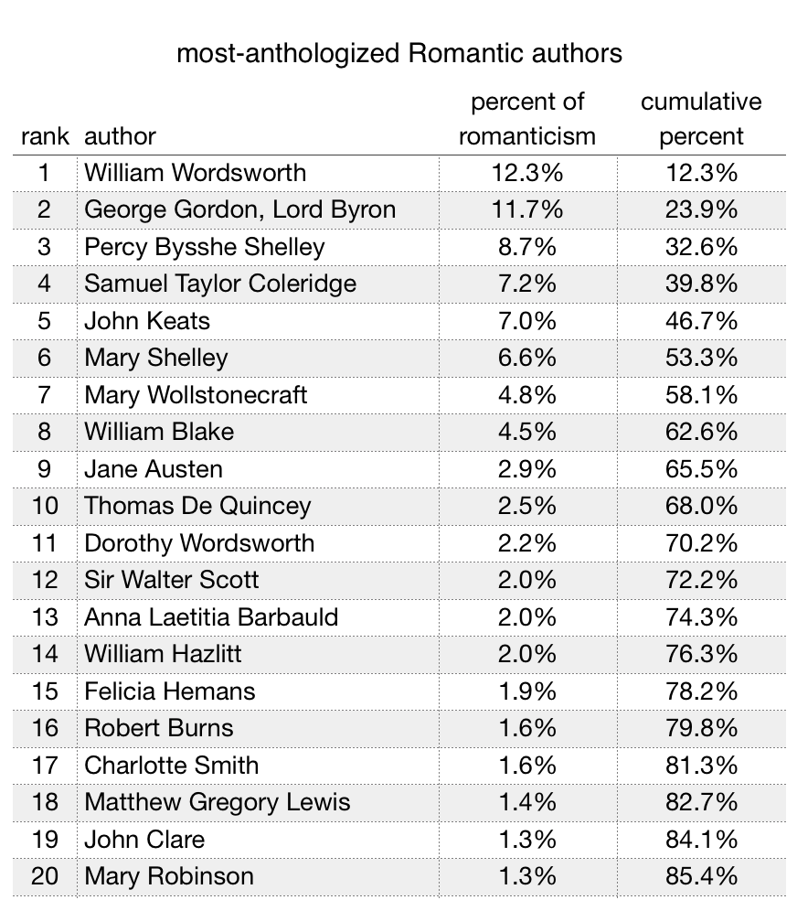sections organized historical events of ideas, this means our model of Romanticism will be small group of important people.

Figure : Top 20 most-anthologized Romantic authors.

Specifically, we learn that Romanticism is 12% Wordsworth by volume. He only barely edges out Byron, who also rounds to 12%. Wordsworth, Byron, Percy Shelley, Coleridge, Keats, and Mary Shelley[4] together account for half of Romanticism; everybody else combined constitute the other half. This is, of course, the “big six,” but with William Blake in 8th place, after Mary Wollstonecraft, slightly outnumbered by women who wrote works that are longer and less visual.

My description of this model is not meant to surprise, but it does, I think, highlight the uncomfortable strategies necessary to reconcile a broadening canon with what William St. Clair calls the “parade of authors” structure of literary history. To counteract the promulgation of a masculinist Romanticism, but remain “teachable,” these anthologies largely keep their original canon, but supplement it with “nearby” women. Tokenism as a strategy can in fact be quite effective, but would be more effective if the women selected were presented as less contingent on the established men.

The obligatory anthologizing of Dorothy Wordsworth, for example, strikes me as misguided. Her journals are fascinating documents, but they are also private, not constructed as literature.[5] Even the concept of “the Grasmere Journal” as a distinct entity reflects an interpretation meant to serve scholars’ interest in her brother, rather than a full understanding of the documents themselves. For example, the second manuscript included in “the Grasmere Journal,” in addition to other fascinating miscellany reflecting the books’ previous use, contains diary entries from a 1798 trip to Germany — a period of her life which does not have a named Journal, so far as I can tell, because William did not describe any major poetic compositions to her during that time. It seems to me to do Dorothy Wordsworth a severe disservice to primarily anthologize the journal entry where she describes the daffodils that her brother later writes into a poem, and the journal entry where she writes feelings about his marriage so private that she crossed them out, and to pretend that these are provided as context for her own small handful of poems. These extracts are too obviously included for William’s sake, not for Dorothy’s. What she teaches us about William is valuable — especially, I feel, in the journal’s grinding descriptions of gardening, cooking, and cleaning, which are clearly as indispensable to the creation of *Lyrical Ballads* as her poetic encouragement — but what is valuable is undermined by the awkward attempt to construct her as an author on equal footing with the many who pursued that career as a public vocation.

Similarly, but with the opposite tendency, Charlotte Smith’s inclusion always near Wordsworth — and actually embedded among the *Lyrical Ballads* as “context” in Longman— gives the entirely false impression that she is interesting primarily for her impact on Wordsworth, rather than as a crucial Romantic poet in her own right. As Knowles and Horrocks point out, Smith was at the centre of the English literary canon in 1798 when *Lyrical Ballads* was printed — her *Elegiac Sonnets* had just entered its eighth edition in 1797, now expanded to two volumes. In one almost shocking recognition of Smith’s importance, John Thelwall describes her sonnets as displaying more skill and genius than those of any other poet in English, “and I certainly do not meant to except the sonnets of Milton” (19). For a poet to go from better than Milton in the eighteenth century to utterly unknown in the nineteenth is a particularly galling example of what Knowles and Horrocks describe as the “cultural ‘forgetting’” of poets who were “relegated to the position of ‘woman writer’ and therefore ‘minor’” (19-20). That Smith ranks within the pages at all is a marked improvement; that she is generally accorded space for the magnificent *Beachy Head* in addition to her compact sonnets, which are easier to sprinkle in as 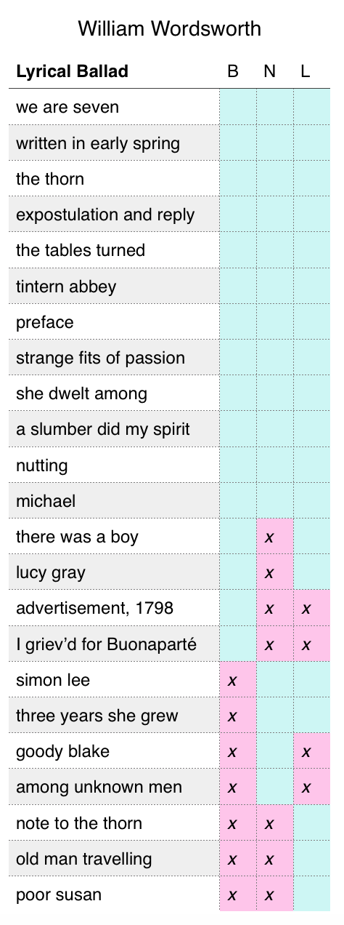flavour is even better; but that she continues under the shadow of Wordsworth, a poet she preceded, calls out for correction.

Figure 3: anthologization of William Wordsworth's Lyrical Ballads.

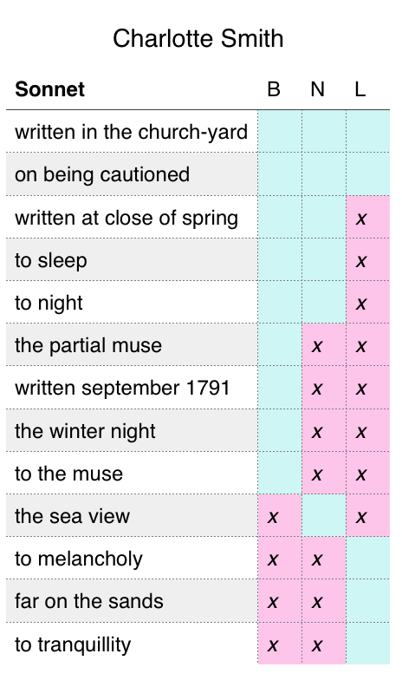However, I will nonetheless respond to the anthologies’ implied assessment of Smith as a Wordsworthian interlocutor, to examine her and Wordsworth as a pair. Wordsworth’s and Smith’s similarities and crucial differences, particularly as regards the way they position their poetry within the public sphere, play out in two of their emblematic, always-anthologized poems, “The Thorn” and “On being cautioned against walking on a headland overlooking the sea, because it was frequented by a lunatic.”

Figure : anthologization of Charlotte Smith's Elegiac Sonnets.

Wordsworth’s “The Thorn,” famously, attempts to depict the sharing of rumours and folk-tales while remaining morally elevated above the circulation of such things, and inculcating in the reader a similar moral superiority. Michael Gamer has astutely described how Wordsworth, in this poem, benefits from the public taste for supernatural and miserable tales, while crafting a serious reputation through a stance of opposition to the materials he uses. The poem’s speaker, too, even as he embellishes the tale with his own imagined details, disavows his sources and attempts to disdain them. He tries to attribute his salacious gossip to the generality, a public matter that “all the country know” and “all and each agree”, by citing sources like “They say,” “some remember well,” “some will say,” “Some say” — but he slips when he mentions “Last Christmas-eve we talked of this,” implicating himself in the conversation, and mentions “grey-haired Wilfred of the glen” as a specific source and personal acquaintance. When he begins a stanza with “one day with my telescope” it almost seems possible that he used the device to spy on her misery, though the anecdote actually resolves into his walk to the mountaintop, where he accidentally meets Martha Ray directly, stares, and flees.

In contrast, Smith’s “On being cautioned” positions her poetic persona as not only the recipient of an alarming tale, but one who pursues that tale intentionally. Some readings of this poem make much hay out of the fact that Smith’s encounter with the eponymous lunatic is imagined, but I note that nowhere does she say that the caution she has been given is *successful*. One can easily read the poem as describing her continued walk toward the precipice. Even if Smith herself did not go, it is in keeping with the poetic persona by which she sold her work for her to imply in her poem that she did. Where Wordsworth attempts to remain “above” the narratives and feelings he sells, Smith embraces her status as the purveyor of emotion, and therefore dramatizes the incident into as direct an encounter as possible. Smith’s poetry is highly-crafted, of course, as the sonnet form demands, but through her craft she cultivates an emotional embrace of direct experience which contrasts strongly with Wordsworth’s distancing aestheticization.

Smith’s poem thus provides a framework through which to critique Wordsworth’s poetic emphasis in his retelling. Smith alludes in her title to the warning she receives to avoid the lunatic, but instead of printing the warning itself, she paraphrases it sympathetically. Embracing him as part of the melancholy seascape that she loves, she tames his potentially-alarming speech into “murmuring responses” to the “frequent sighs” of the wind. In contrast, Wordsworth’s speaker eagerly speaks a lengthy warning of his own — not to avoid the spot, but to “take care and choose your time” to avoid the woman whose presence he then vividly describes. Particularly galling is his advice to “Pass by her door—’tis seldom shut— / And if you see her in her hut—” do not greet her or offer assistance, but “Then to the spot away!” The speaker’s callousness, in his repeated ability to hear misery without sympathy, is obvious in contrast with Smith’s perceived commonality with her lunatic: “I see him more with envy than with fear; / *He* has no *nice felicities* that shrink / From giant horrors.” Wordsworth’s speaker and his listener surely shrink, and are, by Smith’s framework, blamable.

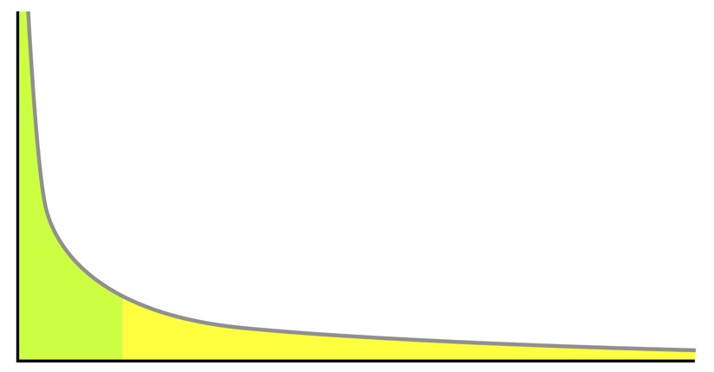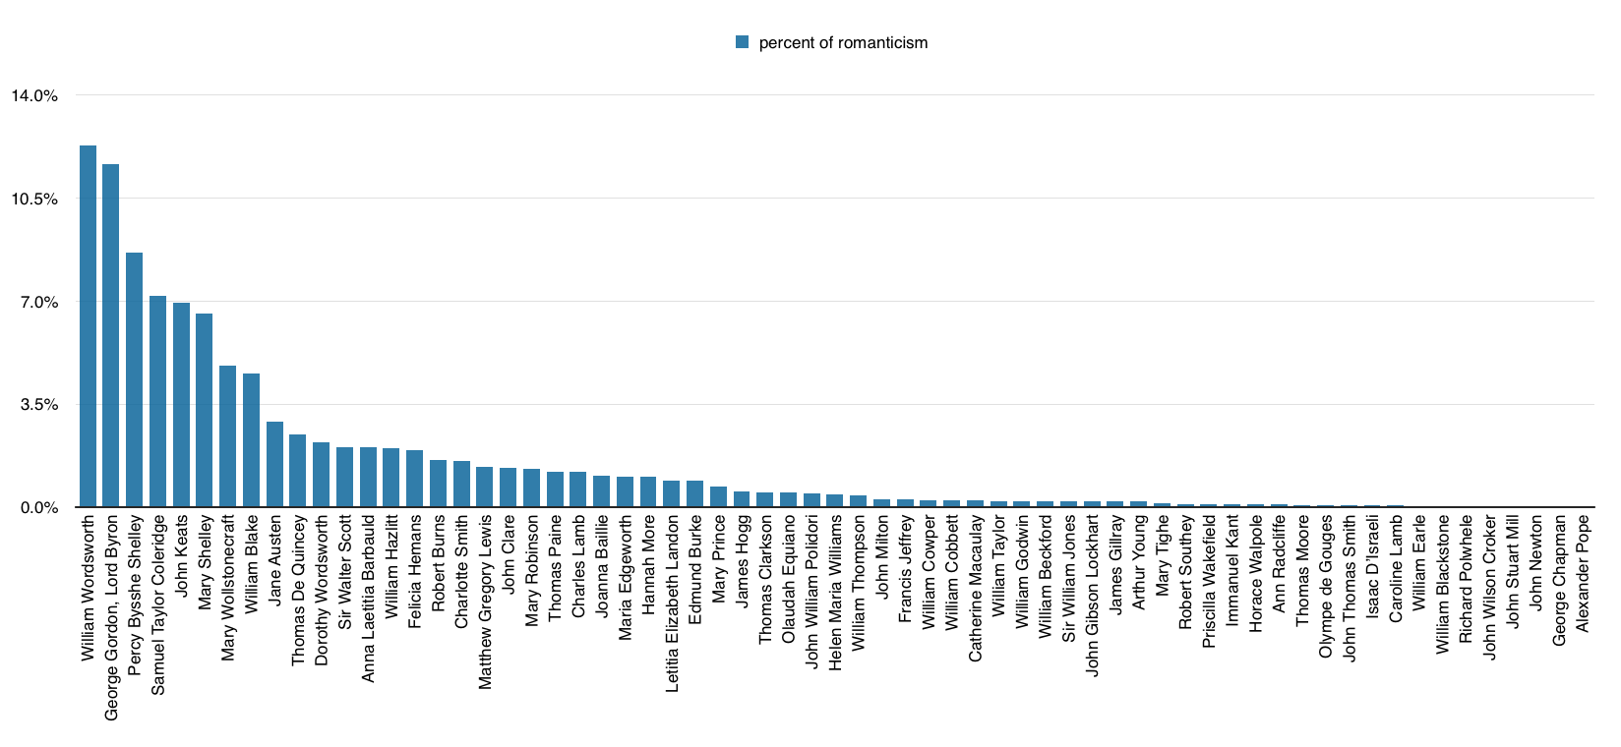But anthologies are not the only place to look for Wordsworth’s peers. If we return to the anthology as a model of Romanticism, and graph the numbers, it can be seen that the distribution of pages by author does not follow a power-law distribution:

Figure 4: Most-anthologized Romantic authors. Note that, due to the methodology of data collection, these numbers are likely to be unreliable for all but roughly the top third of the list, and many minor names are likely to be missing.

Figure 5: A power-law curve, for reference.

Most natural phenomena (and many human phenomena) show a power-law distribution, in which the most frequently-appearing items appear exponentially more than the less frequent items. In any given written work, for example, the most-frequent word (usually “the”) will appear roughly twice as often as the second-most-frequent word, and three times as often as the third-most-frequent word, and so on.[6] A power-law distribution is a particular kind of “long tail” graph, in which the few most frequent items have vastly more impact than the many less frequent items. For Byron to be nearly identical to Wordsworth in prevalence, rather than half Wordsworth, is clear proof that anthologies are selected according to criteria other than naturally occurring frequency.

That anthologies have selection criteria is not meant to be a surprise, either. But it is informative to compare their list against a less-curated body of texts. My point of comparison comes from data I have accumulated for my dissertation: the titles of roughly 52,000 words printed in England between the years 1789 to 1799, as catalogued in the English Short Title Catalogue. Each new edition of a text is counted again in this corpus, a detail I find valuable in determining the popular spread of given texts and authors. These titles constitute the public world of letters in the decade leading up to the publication of *Lyrical Ballads*. Interestingly, this collection of texts *also* does not show a power-law distribution. Unsigned works dominate the corpus so strongly that we diverge from the power-law in the opposite direction (Figure 6 above). Unsigned works represent far more than twice the next “author”. But of course, not all unsigned works are written by Mr. Null, so if we really want to know the most-published individual author, we can exclude them:

Figure 6: Most printed authors, 1789-99

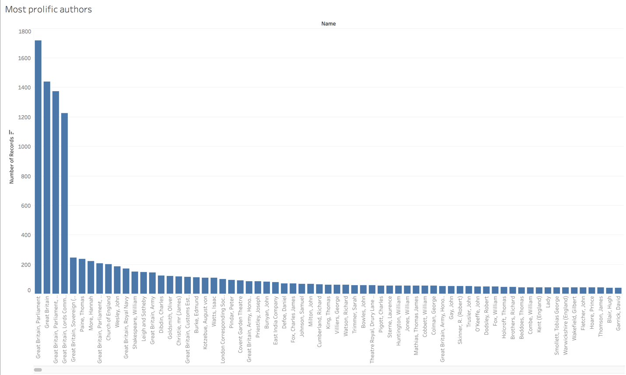

Figure : Most printed named authors, 1789-99.

This time we have four behemoths, all different forms of regular government publications, the third of which also far more than doubles the fifth place author (who, incidentally, is King George III — still the government, but reduced to human scale). If we exclude all works whose “authors” include “Great Britain” or “England” in their names, we at last see something like the list of individual writers which we hoped for[7] (Figure 8 below), but now a much flatter curve, and no names which take up prominence in anthologies of Romanticism.



Figure : Most printed named authors 1789-99 whose names do not include "Great Britain," "England," or other governmental synonyms.

Of course, this decade is before the full flourishing of Romanticism, which makes it an awkward reference corpus at best. If I examined, instead, the years during which *Don Juan* was being published, it is possible that Byron would be visible. But it is also the case that, as William St. Clair has excellently demonstrated, Wordsworth intentionally sought to differentiate his work and its methods of sale from the mass production which puts Thomas Paine and Hannah More at the top of this list.

Wordsworth’s intentional avoidance of mass print, however, does not prevent us from reading “The Thorn” again against another poem making use of gothic materials: Hannah More’s “Robert and Richard, or, the ghost of poor Molly, who was drowned in Richard’s mill pond.” More promises a ghost in the title of this Cheap Repository Tract, likely knowing that it would be competing for sale with other ghost stories among the chapbook hawkers that she used to distribute her Cheap Repository Tracts. More often uses titles in order to attract what she considers “bad readers” toward good texts in disguise; her series “The Two Shoemakers,” for example, makes promises about the ill doings of Jack Brown in prison, to compete with popular true crime narratives, and her evangelical tract “The Cottage Cook; Or, Mrs. Jones’ Cheap Dishes” could easily have been mistaken for one of her actual recipe collections. Similarly, the ghost in “Robert and Richard” is relegated to the sidelines of a rhyming song about Richard who laughs off his misdeeds with “what harm is in this?” and Robert who reminds him to “remember the end.” When Molly does appear, she is seduced, impregnated, abandoned, and mysteriously found drowned with her baby within eight lines. She then rapidly haunts Richard into an early death. But the conclusion of the poem returns its attention to Robert, who continues warning his friend away from drink and gambling, and mourns his friend’s misdeeds and death. The ghost passes away without a trace — “she wept, and she groan'd, and she vanish'd in air” — but Richard’s tale is preserved for posterity in a tombstone erected by Robert, the moralizing epitaph of which concludes the poem.

More, like Wordsworth, uses the marketability of ghost stories to sell her readers on moral improvement, but although she does her selling far more explicitly, she delivers far fewer actual gothic thrills. The ghost is present, but More dedicates no poetic attention to making her spectral appearance scary or even interesting, in striking contrast to the haunting image of the baby’s reflected face in “The Thorn.” As a counter to popular superstition, then, More’s work is formally more in accordance with her stated aims of improvement and elevation than Wordsworth’s. When Wordsworth made his ballads into *lyrical* ballads, comparison with Smith and More shows, he claimed a popular working-class form, disavowed the original speakers of his material, and placed his creation intentionally out of reach of the people he profited from disdaining — all while continuing to focus his attention on the disreputable thrills which he most disavows.

More has not been entirely excluded from anthologies: her “Strictures on Female Education” appears in two anthologies as contextual matter for Mary Wollstonecraft, and “Sorrows of Yamba” in two for the section on slavery, and even “Village Politics” makes one appearance, which may well be sufficient More. And indeed, it is hard to argue for the inclusion of “Robert and Richard” on the grounds of its poetic beauties. But reading Wordsworth alongside a contemporary ballad produces a very different understanding of his literary borrowings than the typical anthology presentation of a few “ancient” ballads at the very beginning of the volume. These slight and sourceless ballads, against which eager students could read Wordsworth’s intervention by flipping back to be beginning of the volume, largely serve to uphold Wordsworth own narrative of personalizing a common raw cultural material. Including as well something like “Robert and Richard” would clarify the extent to which the ballad was a still-living popular form, with prominent political dimensions. Above I took this comparison as an opportunity to emphasize critiques of the poem, but it could also be used to highlight where Wordsworth’s claims of originality are most accurate.

My discussion of Dorothy Wordsworth and Charlotte Smith above also has implications for restructuring these anthologies, but of course, shuffling around a few authors does not address the core problem of the small and highly clustered network of “notable” writers which I argue is to be lost with distant reading. The question of anthology and teaching is not one to be solved here, or it would be solved already; there are real and compelling reasons for anthologies to be organized the way they are.[8] The “canon” has always been an artificial invention to serve the needs and agendas of those who construct it. What this means is not that it is useless, but that we should thoughtfully begin again each time we find that our needs and agendas change. My priorities discussed here move away from the self-defined central concepts of Romanticism, particularly that of the individual genius. The alternative remains unclear. I am inspired by Katherine Bode’s call for scholarly editions of literary systems, and intrigued by Philip Cox’s strictly chronological edition of Keats’ works which mixes letters and poems. My instinct is to step backward, view as many things at once as possible, and begin again from the ground up — which brings me to distant reading, and the attempt to shake off institutional expectations, and build my own.

1. Unlike The Man of Feeling, which caused its original 18th century readers to laugh mere decades later at those parts where they had previously wept, The Vicar of Wakefield enjoyed a long popularity. In the period 1789 to 99, Oliver Goldsmith was still the seventh most printed author. The Vicar of Wakefield went through sixteen editions in those eleven years.
2. Lewis’s letter to his mother reports one woman who fainted in the pit, and one man who went into convulsions in the boxes, “when it was about half over” — I believe he describes the same moment, with a different memory regarding the two people who fainted most spectacularly.
3. My Norton and Broadview anthologies are the most recent editions, but the Longman is two editions out of date; the rest of the Longman series is available in a 4th edition, and Romanticism has reached a 5th edition. However, I was unable to locate library copies of the 4th or 5th editions, despite consulting a range of university and public libraries with which I am connected. I therefore concluded that the 3rd edition of the Longman likely remains in sufficient use that it continues to constitute an appropriate object of study.
4. Much of Mary Shelley’s prominence is due to the inclusion of the entirety of Frankenstein in the Longman anthology; without it, she falls to tenth place, after Mary Wollstonecraft, William Blake, Jane Austen, and Thomas De Quincey, and Mary Wollstonecraft takes her place as the sixth writer making up half of Romanticism.
5. There is some precedent for including private documents in anthologies. Letters by Byron and Keats appear in all three anthologies, with letters from Charles Lamb, Jane Austen, Mary Shelley, Percy Shelley, and William Blake appearing in some. However, letters appear to have been less private than journals in the eighteenth century, often copied, read in groups, and even printed. In contrast, Dorothy Wordsworth’s frequently-anthologized entry on William’s marriage is, Pamela Woolf describes, “heavily covered with ink, not in order to correct or emend, but to make the words impossible to read.” Woolf observes that “D herself, either soon afterwards or in later life, could have been the one to cross out the sentences, realizing as she must have, that the drama of tenderness of that morning was perhaps played over-consciously and in any case was not for other eyes — not even perhaps for W’s” — and then sanguinely describes how the naked eye can nonetheless make out the words under a bright light, unlike other sections which required X-rays to extract the words Dorothy sought to conceal.
6. Another way of explaining this: Zipf's law states that given a large sample of words used, the frequency of any word is inversely proportional to its rank in the frequency table. So word number N has a frequency of 1/N. Thus the most frequent word will occur about twice as often as the second most frequent word, three times as often as the third most frequent word, etc. For example, in one sample of words in the English language, the most frequently occurring word, "the", accounts for nearly 7% of all the words (69,971 out of slightly over 1 million). True to Zipf's Law, the second-place word "of" accounts for slightly over 3.5% of words (36,411 occurrences), followed by "and" (28,852). Only 135 vocabulary items are needed to account for half the sample of words. The same relationship occurs in a wide range of other rankings, unrelated to language, such as the population ranks of cities in various countries, corporation sizes, and income rankings.
7. Whether it is the appropriate response to consider seeking individual authors after discovering by these first two results the prominence of “non-authored” texts is a matter for another day.
8. On a very practical level, I initially scoffed at an online review of the Broadview anthology that complained that works by each author were too widely distributed throughout the volume, until I was in the position of frequently trying to look things up. The implications of editorial decisions are practical as well as interpretive.